Michael Colistro

0488092

Bonus 5

COMP4413

Dr Sabah Mohammed

1) The grammar type is a Context-Free Grammar

2)

i) Rejected

ii) Accepted

iii) Accepted

iv) Accepted

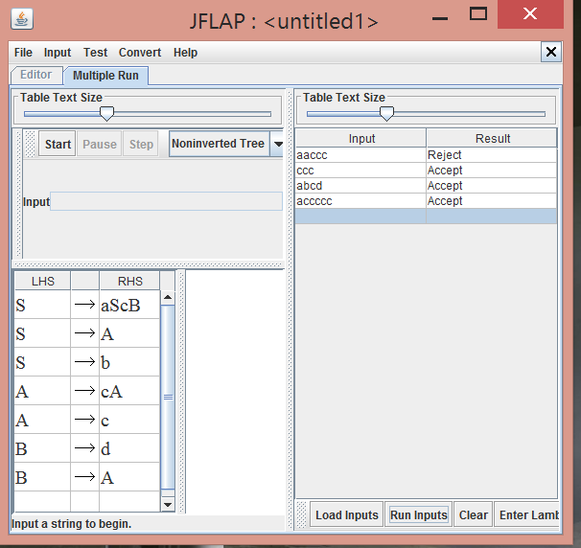

This is the DFA converted from the grammar

